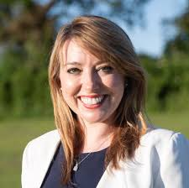

**SARAH BOOL MP**

**MEMBER OF PARLIAMENT FOR SOUTH NORTHAMPTONSHIRE**

WILL BE AT

YARDLEY GOBION VILLAGE HALL

ON THURSDAY 14TH AUGUST

FROM 12.15 – 1.30

**COME ALONG TO SHARE ANY CONCERNS YOU HAVE ABOUT LOCAL ISSUES**